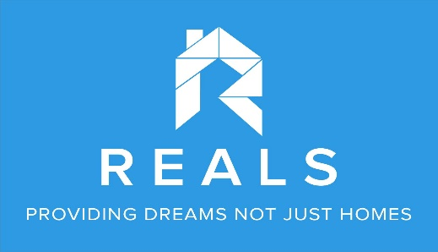

Lead Brokerage Agreement

This agreement between REALS CORPORATION as the brokerage firm and ____________________ as the property owner of____________________________ is valid for ______________duration starting ____________________.

REALS CORPORATION (as the broker) will do the best it can to sell the property of the owner such as the following but not limited to:
- Recruit and train all the interested brokers and agents including the owner’s referrals
- Advertise/market online and offline
- Use the REALS office and company’s vehicle for the tripping every time the clients’ need it and every time the accredited agents/brokers need it
- Do the sales and clients’ orientation
- Facilitate in the documentation needed during sales and after sales
- settle the commission distribution

_____________________ as the property owner will
- (__) will give ___________% commission to REALS Corporation based on the total selling price of the property or (__) get a net income of __________________ and leave the rest of the sales proceeds to REALS corporation to pay for all the taxes, commissions and other miscellaneous fees.
- will only deal with REALS corporation as his/her lead broker to market, recruit agents and sell the property until the agreed time expires or the property gets sold whichever comes first. In the moment that this agreement expires and the property is still not successfully sold, the owner will have the right to look for another lead broker.

__________________________________ ______________________________
Property owner

__________________________________
REALS corporation representative

